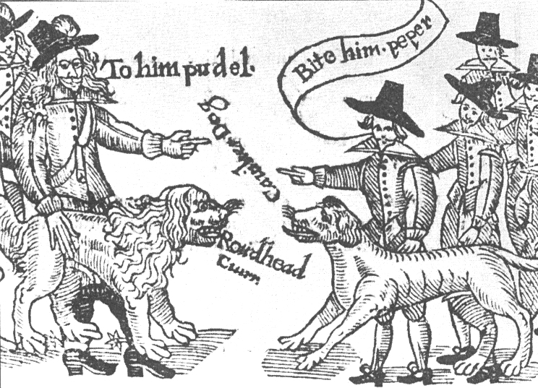
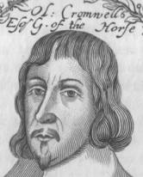
A DECADE OF TURMOIL……. THE ENGLISH CIVIL WAR
Use the information on these pages to complete a timeline of the main events.
1. Charles I crowned in 1625 was a religious man who believed he had been chosen by God to rule the country. He chose to rule without calling parliament for 11 years from 1629 because they disagreed so much. Events came to a head in 1642 over the need to raise an army after quarrels with both the Scots and the Irish. Charles decided to act and with some soldiers went to arrest the five leaders of parliament. They escaped, but both sides prepared for war.
2. Fighting began with the indecisive battle of Edgehill (Warwickshire) in 1642. This was followed by the battles of Brentford and Turnham Green. In this cartoon of 1642, the war is compared to a dog fight between ‘ROUNDHEAD’ and ‘CAVALIER’. These were terms of abuse coined by the opposite sides…. Meaning anti-protestant Spanish troopers, and shorthaired anti-catholic parliamentarians.
3. Events in 1643 went mostly for the King, but the tide turned in 1644 when parliament won a major victory at Marston Moor (near York) and again the following year at the battle of Naseby (Northamptonshire) using a new and stronger army called the New Model Army. Both battles were won by the parliamentarian cavalry under Oliver Cromwell. He was a brilliant commander and had highly disciplined troops. He believed that he had been chosen by God to free England of Charles’ reign.

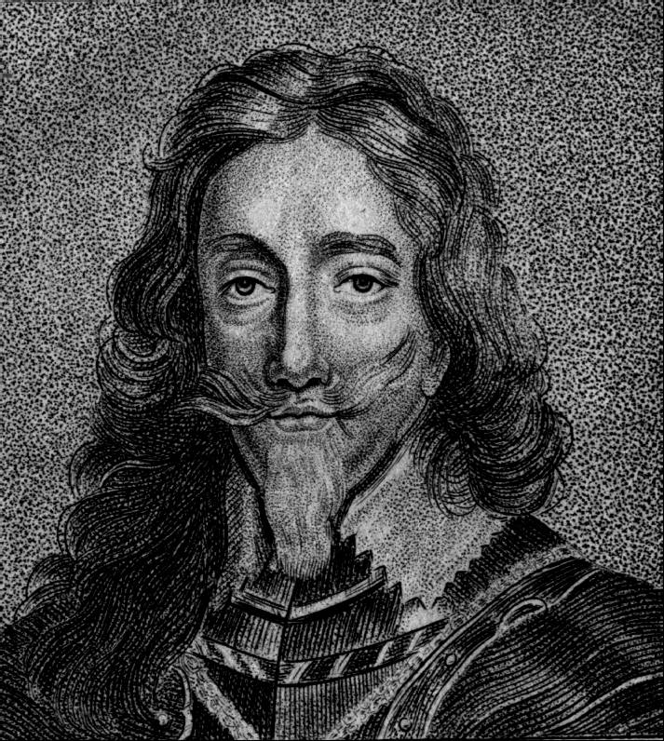

4. Charles surrendered to the Scots, who had sided with parliament, in May 1646. Fighting flared-up again in 1648 after the King had persuaded the Scots to join his side. Because he had started the war again, Cromwell, the New Model Army and some in parliament decided Charles should be executed. He had been held prisoner on the Isle of Wight until being brought to London in 1649, put on trial and beheaded.
5. From 1649 to1660 England had no monarchy. Fighting continued in Scotland and Ireland and in 1651 the Scots tried to invade England to put Charles’ son, the future Charles II, on the throne. But Cromwell defeated the Scots at Worcester. In 1653 Cromwell was made Lord Protector of England – a king in all but name – until his death in 1658. Cromwell’s son tried to rule England after his father, but Charles’ son returned and was crowned King in 1660.

4. Charles surrendered to the Scots, who had sided with parliament, in May 1646. Fighting flared-up again in 1648 after the King had persuaded the Scots to join his side. Because he had started the war again, Cromwell, the New Model Army and some in parliament decided Charles should be executed. He had been held prisoner on the Isle of Wight until being brought to London in 1649, put on trial and beheaded.

5. From 1649 to1660 England had no monarchy. Fighting continued in Scotland and Ireland and in 1651 the Scots tried to invade England to put Charles’ son, the future Charles II, on the throne. But Cromwell defeated the Scots at Worcester. In 1653 Cromwell was made Lord Protector of England – a king in all but name – until his death in 1658. Cromwell’s son tried to rule England after his father, but Charles’ son returned and was crowned King in 1660.

Date

1625

1629-1640

1642

1644

1646

1649

1649-1660

1651

1660

3. Events in 1643 went mostly for the King, but the tide turned in 1644 when parliament won a major victory at Marston Moor (near York) and again the following year at the battle of Naseby (Northamptonshire) using a new and stronger army called the New Model Army. Both battles were won by the parliamentarian cavalry under Oliver Cromwell. He was a brilliant commander and had highly disciplined troops. He believed that he had been chosen by God to free England of Charles’ reign.
3. Events in 1643 went mostly for the King, but the tide turned in 1644 when parliament won a major victory at Marston Moor (near York) and again the following year at the battle of Naseby (Northamptonshire) using a new and stronger army called the New Model Army. Both battles were won by the parliamentarian cavalry under Oliver Cromwell. He was a brilliant commander and had highly disciplined troops. He believed that he had been chosen by God to free England of Charles’ reign.
4. Charles surrendered to the Scots, who had sided with parliament, in May 1646. Fighting flared-up again in 1648 after the King had persuaded the Scots to join his side. Because he had started the war again, Cromwell, the New Model Army and some in parliament decided Charles should be executed. He had been held prisoner on the Isle of Wight until being brought to London in 1649, put on trial and beheaded.
5. From 1649 to1660 England had no monarchy. Fighting continued in Scotland and Ireland and in 1651 the Scots tried to invade England to put Charles’ son, the future Charles II, on the throne. But Cromwell defeated the Scots at Worcester. In 1653 Cromwell was made Lord Protector of England – a king in all but name – until his death in 1658. Cromwell’s son tried to rule England after his father, but Charles’ son returned and was crowned King in 1660.

