During the Civil War foot soldiers were organised in companies commanded by a Captain. A Lieutenant, an Ensign, Sergeants and Corporals helped the Captain. At full strength a company was about 100 soldiers. There were usually between eight and ten companies in a regiment. A regiment was commanded by a Colonel.
SOLDIERS OF THE ENGLISH CIVIL WAR

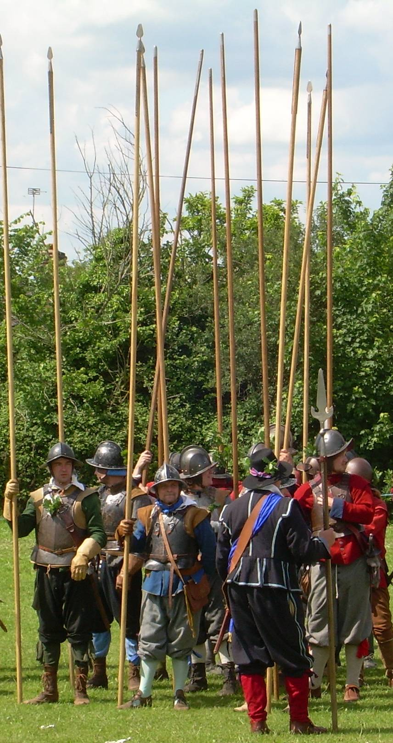
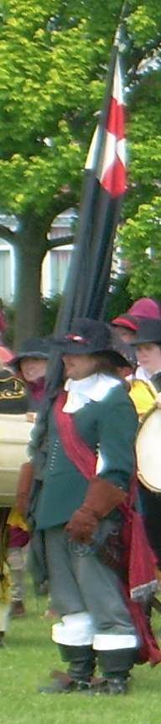
Musketeers were armed with a matchlock musket. In battle they stood in two blocks either side of a block of pikemen. The first rank of soldiers fired their weapons and then filed to the back to reload as the next rank fired.
The Ensign was the most junior officer. He carried the company flag, which helped the soldiers see where they should be if they got lost on the battle-field. In battle the ensign stood in front of the pikemen on the left side.

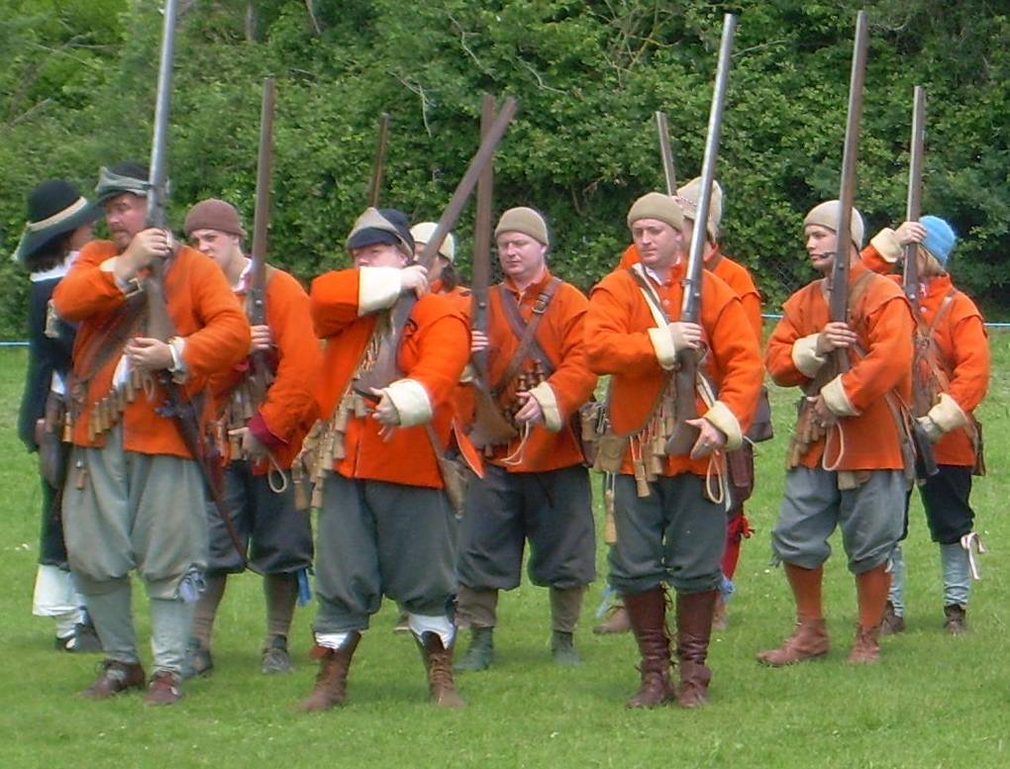

Pikemen were armed with 5 metre long pikes. In battle they stood in a block and protected the musketeers from enemy cavalry. Sometimes they fought enemy pikemen.

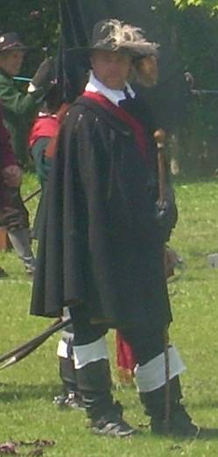
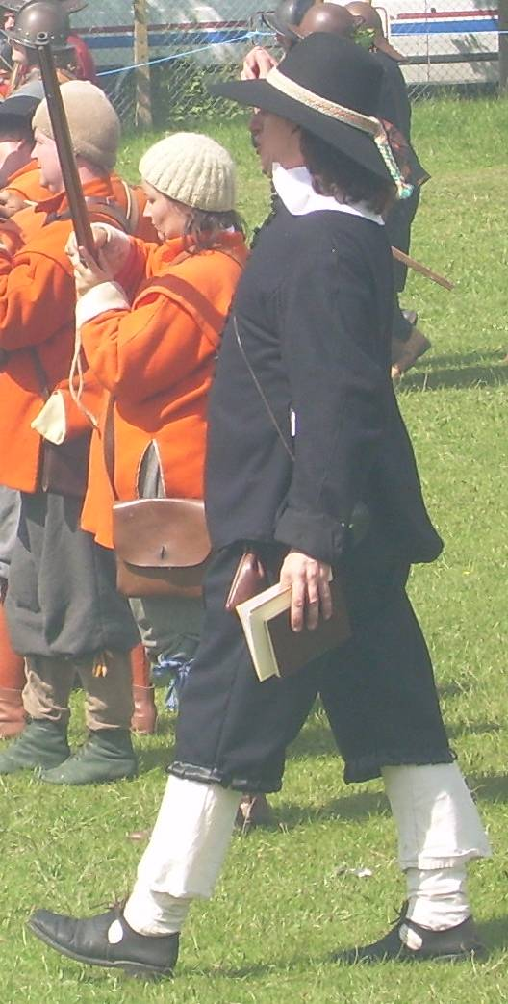
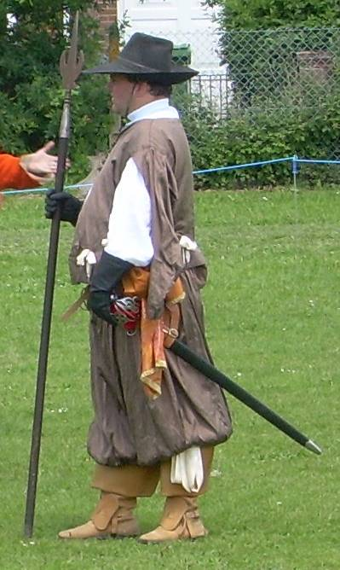
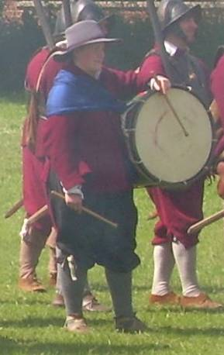

The Captain commanded the company. Armed with a sword and pistol, in battle he stood in the centre in front of the pikemen.

There was one Chaplain in each regiment. He led the soldiers in prayers and had them sing hymns in battle to raise their spirits.
Each company had two Drummers. Armed with a sword, they signalled actions to the soldiers over the noise of battle using a drum. In battle they stood at the front between the pike and musket blocks.
Each company had two Sergeants. They were armed with a halberd (an axe on a 1.5 metre pole) and a sword. In battle they stood at the front and on the outside of the blocks of musketeers.

Activity
a. This is a company drawn up for battle. Using the information above label the blocks of pikemen and musketeers and then show where the Captain, Drummers, Ensign and Sergeants stood by writing the first letter of their job on the plan (eg for Captain write ‘C’).

P
M
M

Equipment
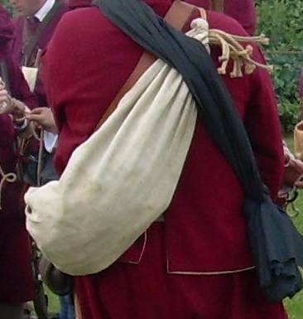
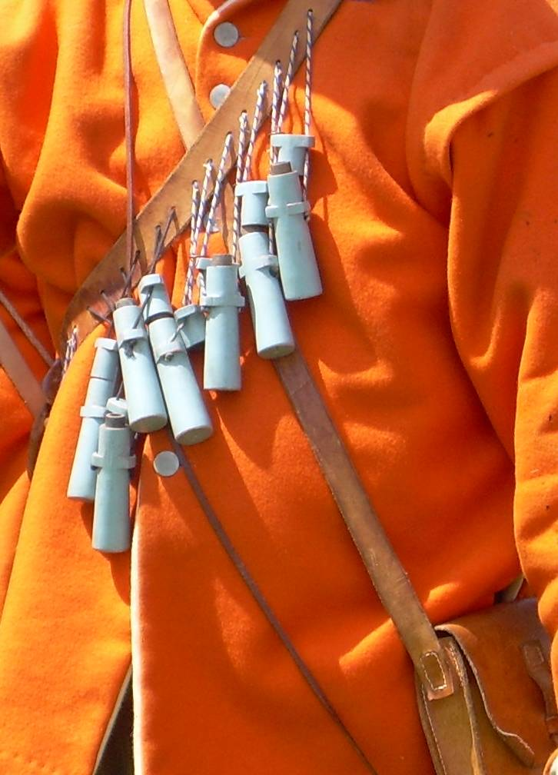
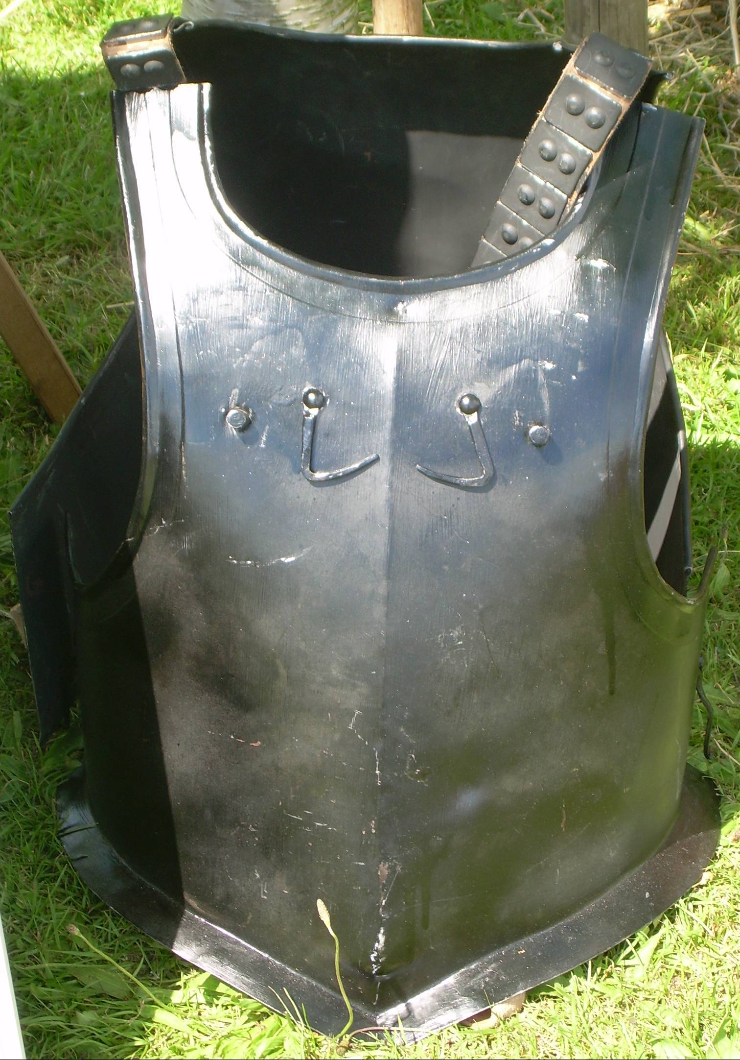
Knapsacks were used by all soldiers to hold their food, spare clothes and personal items.
Bandoliers were used by musketeers to hold single measures of gun powder for their muskets.
Breast and back armour was used by cavalry and some pikemen to protect themselves.
Matchlock muskets were loaded by putting gun powder and a bullet down the barrel. They were fired using a burning piece of cord. Muskets were noisy and inaccurate.
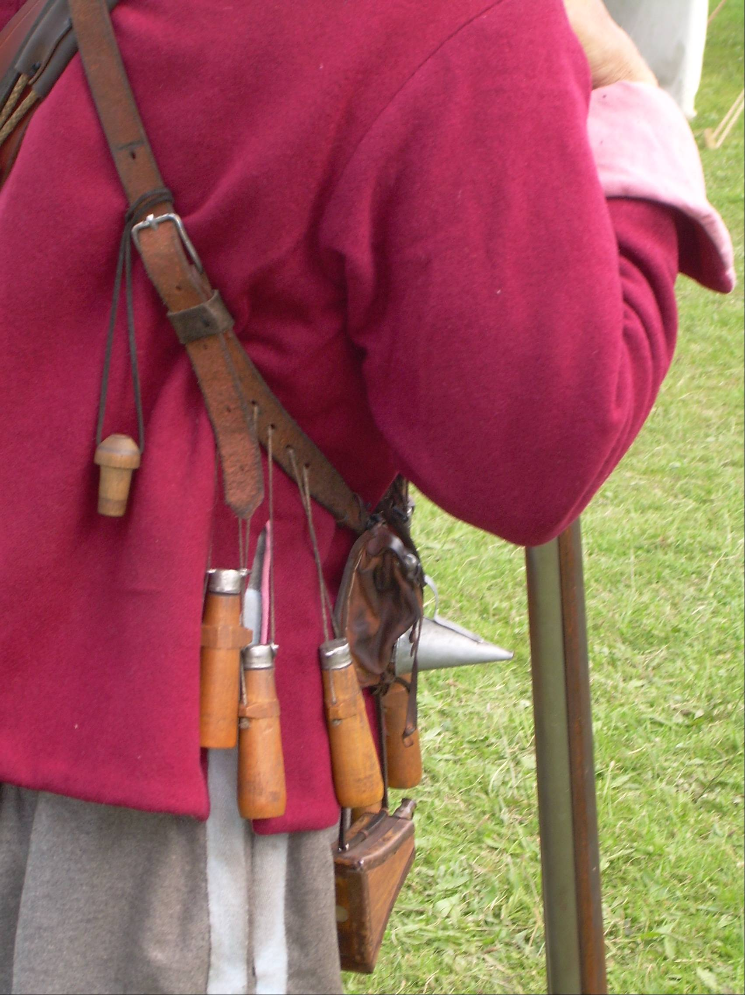
Each soldier was given a coat, shirt and shoes. In a regiment, all the coats were the same colour so the soldiers could identify each other.
Pistols were used by cavalry and officers on foot. They were loaded like muskets, but used the spark from a flint to fire. They had a short range.
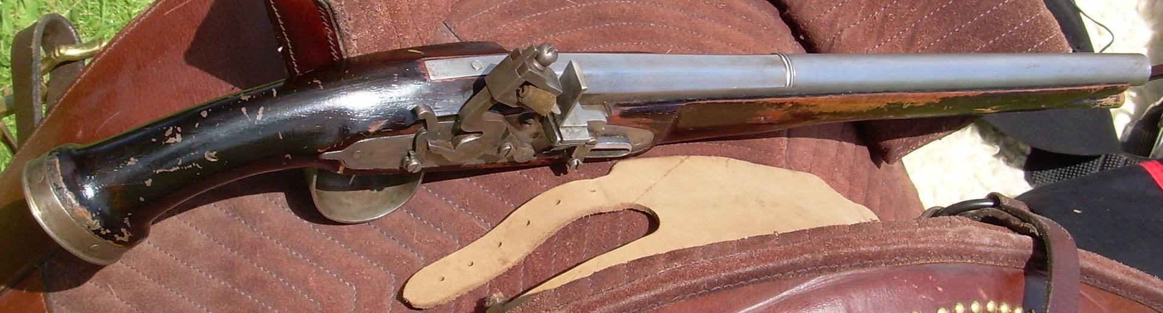

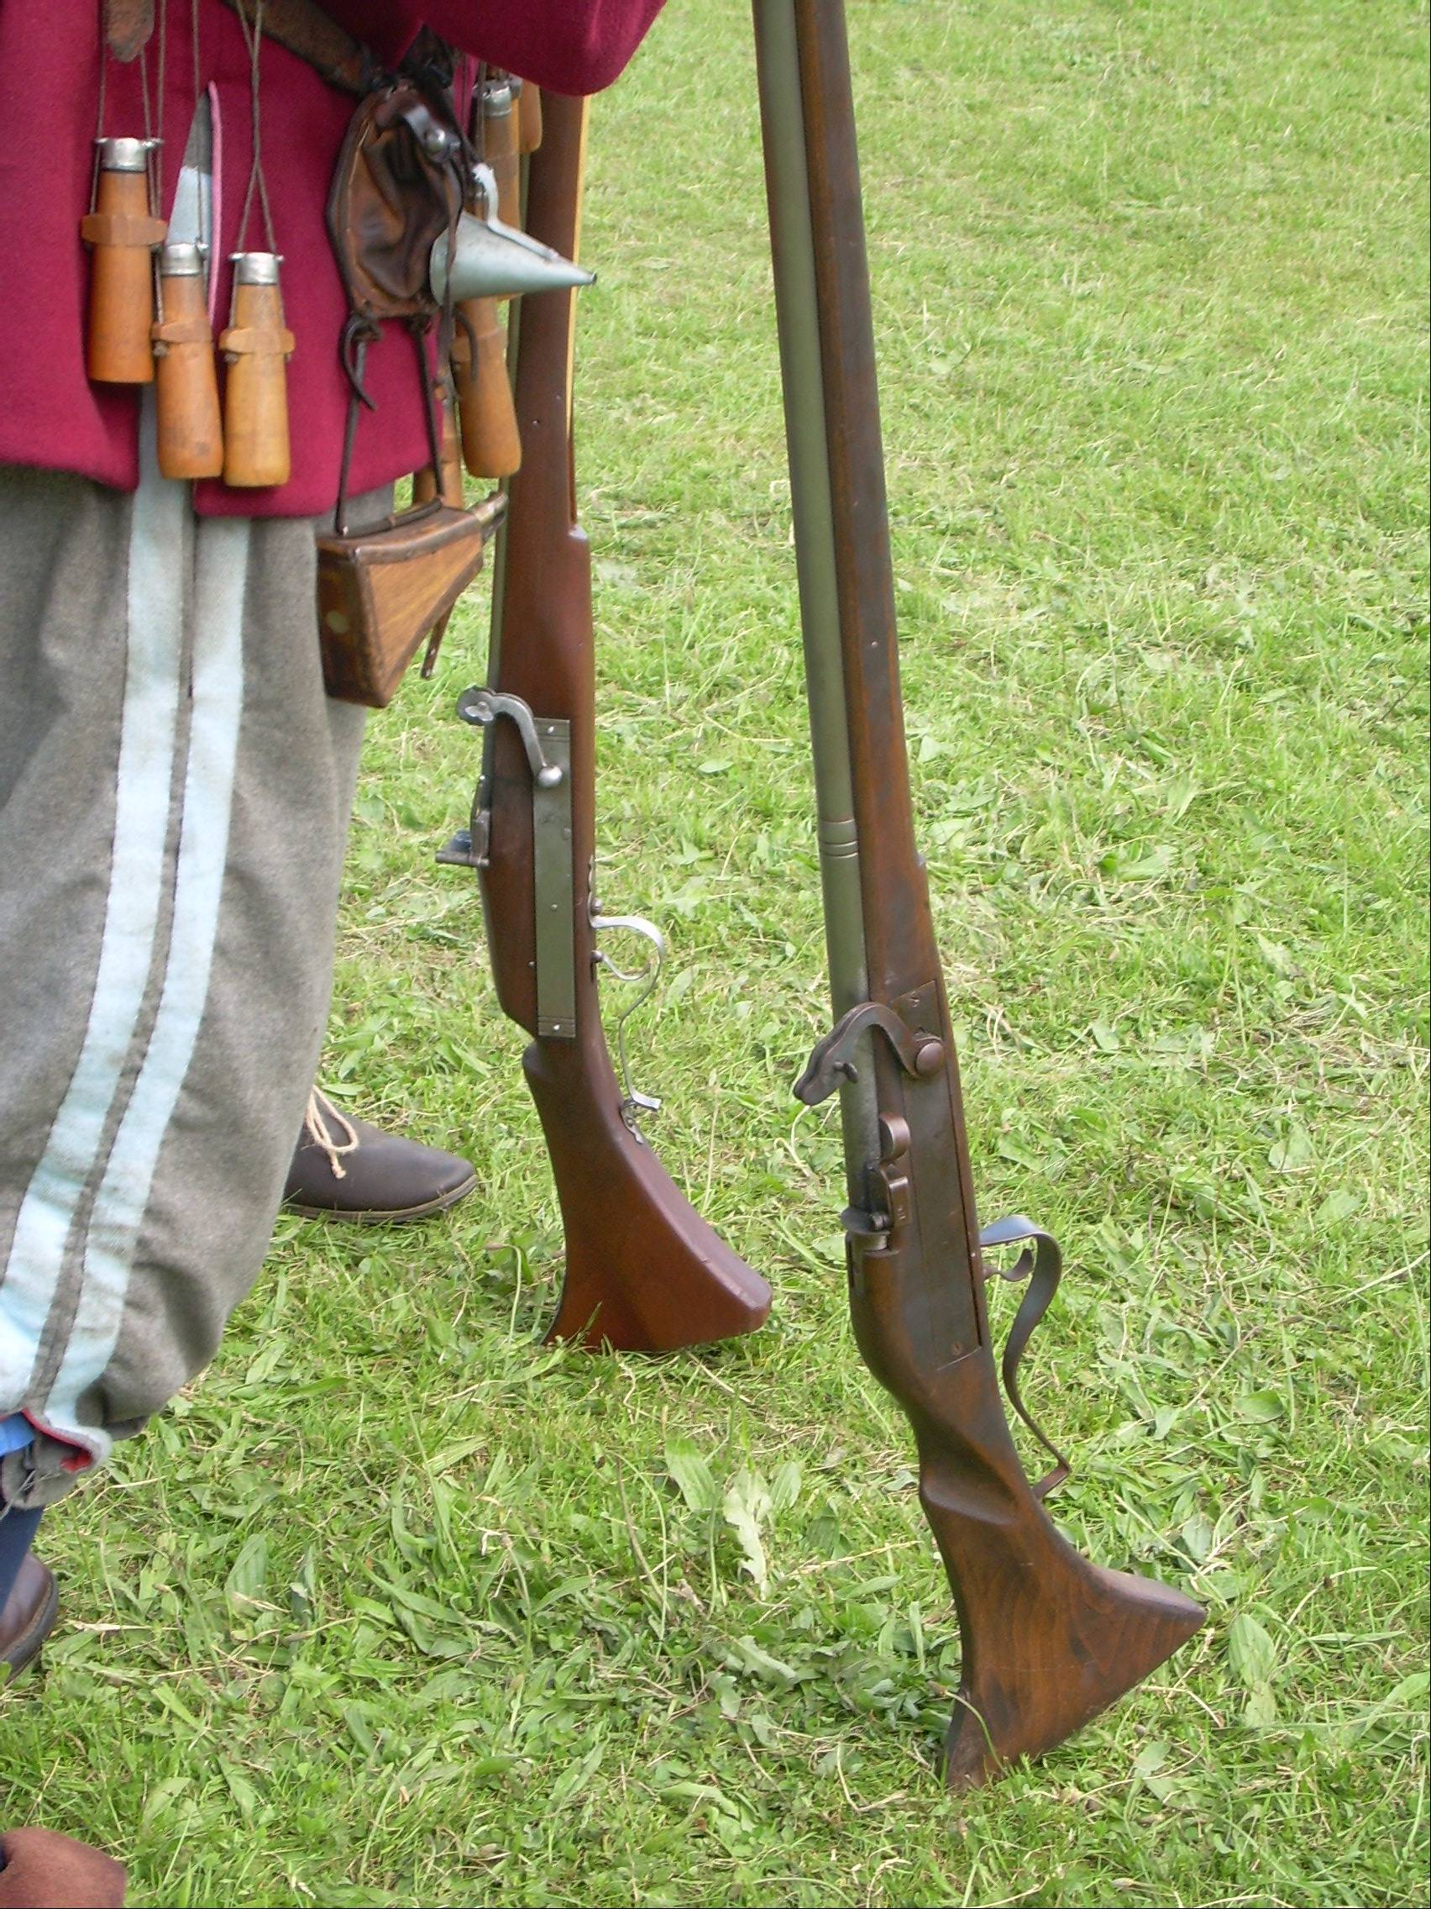
Activity
a. Choose one of the types of soldier described in the first section and on a separate piece of paper draw a picture of him and label his equipment.
b. Imagine you are a soldier standing in battle formation. On another piece of paper describe what you are wearing and what equipment you have. Say what those around you look like and what they are doing. What sounds and smells can you sense? Describe the scene.

