A REQUISITION FOR YOUR COMPANY
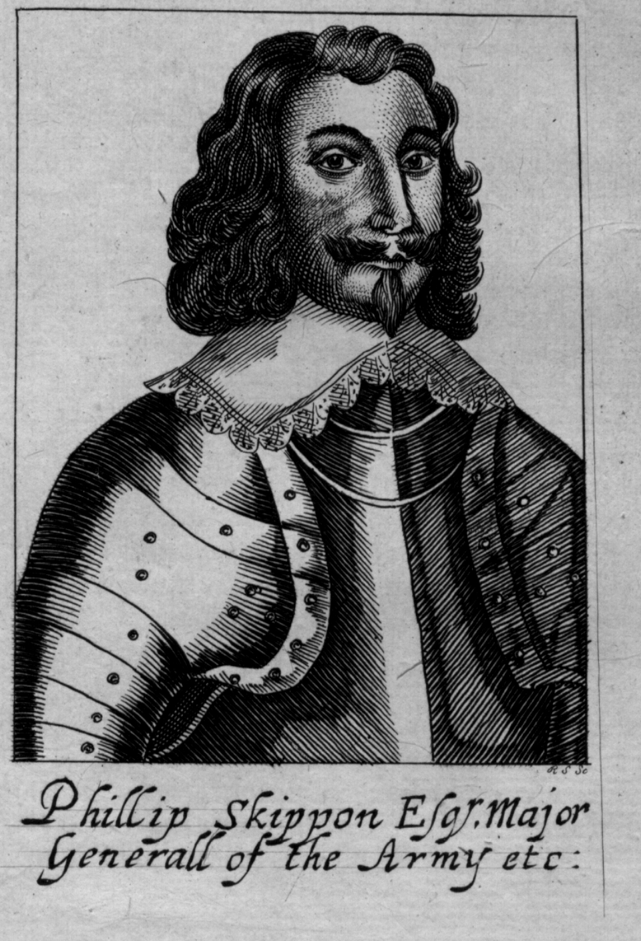

Below is an actual requisition (request) for clothing for the regiment of Major General Philip Skippon (That’s him on the left). He was in command of the part time parliamentarian soldiers (militia) at the Battle of Turnham Green.

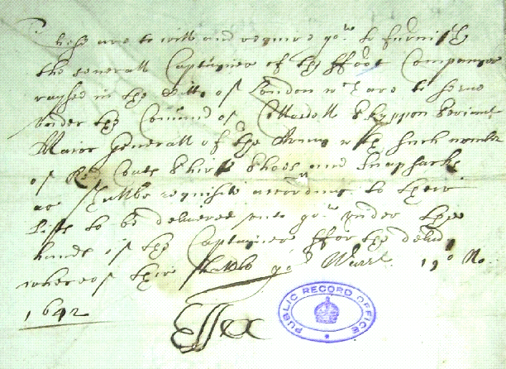
Clothing Warrant for the
Regiment of Philip Skippon
Roughly translated the authorities have ordered red coats, shirts,
shoes and backpacks to be given to Skippon’s foot soldiers.
Can you pick out odd words like ‘captaynes’ (captain) and ‘ffoot
companyes’ (foot companies) on the 2nd line: ‘London’ on the 3rd line:
red coats, shirts, shoes and snapsacks’ on the 6th line. Note how some
spellings are different to ours. At least the date is clear!
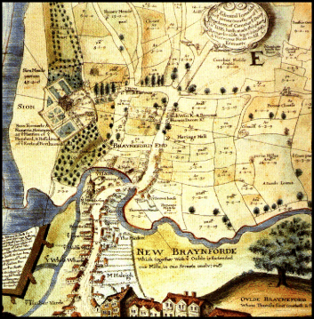
Brentford, in 1642, was a small but prosperous market town consisting of one main street, lined with houses and shops. It had a church, St Lawrence's, on the south side of the road. Syon House was close by, and there were fields to the west, north and east of the town. We know that there was a bridge over the River Brent, a tributary of the Thames. The bridge had 3 arches and was made of stone. There would previously have been a ‘ford’ or crossing point here.
Brentford, in 1642, was a small but prosperous market town consisting of one main street, lined with houses and shops. It had a church, St Lawrence's, on the south side of the road. Syon House was close by, and there were fields to the west, north and east of the town. We know that there was a bridge over the River Brent, a tributary of the Thames. The bridge had 3 arches and was made of stone. There would previously have been a ‘ford’ or crossing point here.
R____________

T____________
Try your calligraphy. Your task is to write a requisition for food for your company for one week. Soldiers in those days had half a kilogram of bread and a quarter of a kilogram of meat (or cheese) a day. They also received a bottle of wine (or two bottles of beer) every day. If food was in short supply peas and beans might be issued instead with which the soldiers would make broth.
Have a go. You have 100 soldiers under your command who need feeding. Try an ’olde English’ style of writing. Sign and date it.

Try your calligraphy. Your task is to write a requisition for food for your company for one week. Soldiers in those days had half a kilogram of bread and a quarter of a kilogram of meat (or cheese) a day. They also received a bottle of wine (or two bottles of beer) every day. If food was in short supply peas and beans might be issued instead with which the soldiers would make broth.

Have a go. You have 100 soldiers under your command who need feeding. Try an ’olde English’ style of writing. Sign and date it.

