THE BATTLE OF TURNHAM GREEN
Fresh from victory the day before at Brentford, the royalists (the King’s army) planned to capture London. But the parliamentarians brought together and army of 24,000 men on Turnham Green and the open spaces around it to stop them advancing. Commanded by the earl of Essex and Major General Skippon, this force was a mix of professional and part time soldiers. The battle started with the royalists sending troops onto the hedgerows to the north towards. The earl of Essex sent foot soldiers and horsemen to drive them out. Artillery fire and advances of cavalry troopers continued throughout the day, but by late afternoon the royalists withdrew through Brentford to Hounslow Heath. The battle had no result one way or the other, but at least the royalist advance on London was halted.

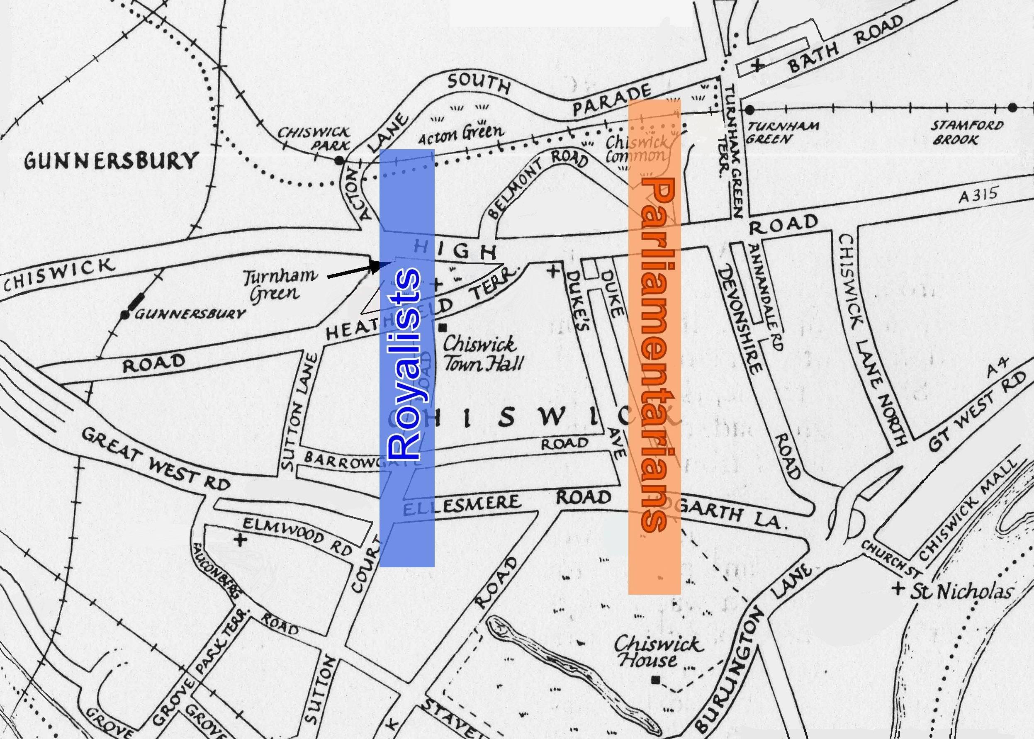
The two armies formed up on the open spaces of Turnham Green, Acton Green and Chiswick Common Field, much of which has now been built over

This is a modern day street map showing the road names and tube line

An Extract from Bulstrode Whitelock’s Diary
“13 November 1642: ....I decided not to tell my wife that I was going to the battlefield and, being there, thought it best to join a troop or a company as a volunteer soldier. My relation, Colonel Hampden, said I could fight with his regiment and I chose to carry a pike under him. I went with his soldiers up a lane from Turnham Green toward Acton, where some of our men and horses were killed by the King’s soldiers that lined the hedges. But we forced the King’s men to retreat. The earl of Essex, our General, ordered two regiments of horse and four of foot to march to Acton and get behind the King’s forces and then attack them. As Hampden’s regiment was one of these, I marched with them and after about a mile I saw the King’s soldiers looking in surprise at our advance. Sir John Merrick, who was in charge of the foot soldiers in the army, then came galloping up with orders from the earl of Essex that we should return to Turnham Green. As Sir John was my friend, I asked him why the earl had changed his mind as we had a great advantage over the King’s army. Sir John said he thought some men had given bad advice to the earl. Colonel Hampden, joking, told Sir John not to say such things or he might be shot for causing trouble in the army. We then retreated back to Turnham Green where our whole army stood in battle formation for many hours.....”

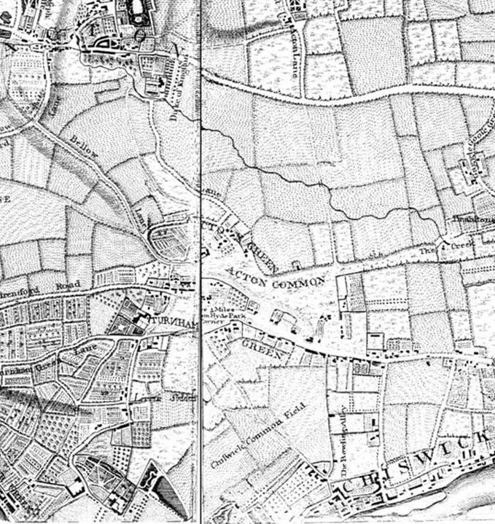
This map was drawn by John Rocque in 1746, but it is close to how Turnham Green looked in 1642. Read Bulstrode Whitelock’s account of part of the battle of Turnham Green below. See if you can use the map to work out where he marched. Draw where he went on the map and label it.
Using the modern street map on the left draw on the Rocque map where you think the royalist and parliamentarian armies might have been positioned? Draw and colour in rectangles to show them on the map and label them.
Imagine you were a soldier marching with Bulstrode Whitelock to Acton. Write a letter to your mother, describing what you did, what you saw, what sounds you heard.
This map was drawn by John Rocque in 1746, but it is close to how Turnham Green looked in 1642. Read Bulstrode Whitelock’s account of part of the battle of Turnham Green above. See if you can use the map to work out where he marched. Draw where he went on the map and label it.
Using the modern street map above draw on the Rocque map where you think the royalist and parliamentarian armies might have been positioned? Draw and colour in rectangles to show them on the map and label them.

Imagine you were a soldier marching with Bulstrode Whitelock to Acton. Write a letter to your mother, describing what you did, what you saw, what sounds you heard.

