THE BATTLE OF BRENTFORD

The battle took place on 12 November 1642. The King’s army advanced from the west (see map below). The parliamentarians put-up a barricade at Brentford Bridge (see painting) and were attacked and defeated by the King’s men. They then overcame a second barricade manned by more parliamentarian foot soldiers. Some of the defeated soldiers ran back to London, others fled into the Thames and were drowned.

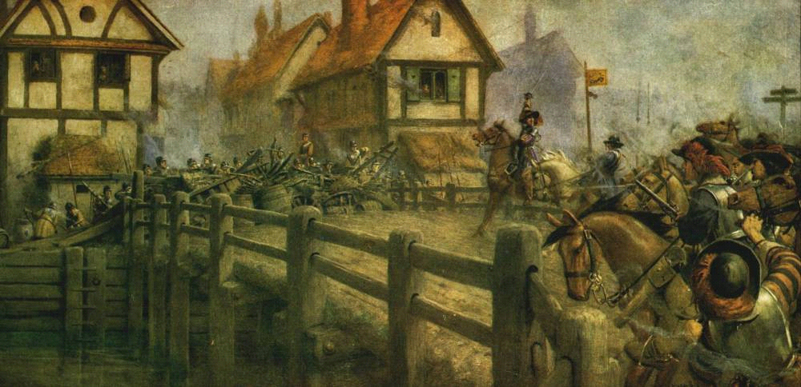
This reconstruction of the scene was painted in 1928

Look at the painting above and use the other information on this sheet to answer the questions below.
1. Is the painting an example of primary evidence (painted at the time), or secondary evidence?
____________________________________________________________________________
2. Do you think that this makes the reconstruction completely accurate? (If not why not?)____________________________________________________________________________________________________________________________________________________________
3. Where is the attack by the King’s soldiers coming from…The west or the east?_________
4. What do we know about the construction of the bridge, does the bridge in the painting seem accurate? If not why not?_________________________________________________________
_______________________________________________________________________________________
5. Describe what weaponry and armour can be seen in the painting. _____________________
________________________________________________________________________________________
6. Look at the map opposite. Why do you think it was important for the parliamentary troops to defend (hold) the bridge? ________________________________________________________________________________________
________________________________________________________________________________________
7. What must it have been like to live in the house by the bridge on the morning of the battle?
________________________________________________________________________________________________________________________________________________________________________________

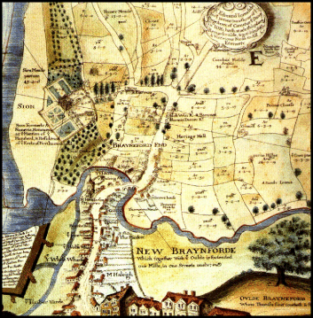
Brentford, in 1642, was a small but prosperous market town consisting of one main street, lined with houses and shops. It had a church, St Lawrence's, on the south side of the road. Syon House was close by, and there were fields to the west, north and east of the town. We know that there was a bridge over the River Brent, a tributary of the Thames. The bridge had 3 arches and was made of stone. There would previously have been a ‘ford’ or crossing point here.
S____________

H____________
R____________

T____________
B____________

B____________
R____________

B____________
On this map:-
1. Label neatly the River Thames, River Brent, Syon House and Brentford Bridge.
2. Shade the rivers in blue.
3. Next to the arrows write ‘Royalist army’
4. The barricades have been marked by black lines. Label these ‘Parliamentary forces’
WEST
EAST
Brentford, in 1642, was a small but prosperous market town consisting of one main street, lined with houses and shops. It had a church, St Lawrence's, on the south side of the road. Syon House was close by, and there were fields to the west, north and east of the town. We know that there was a bridge over the River Brent, a tributary of the Thames. The bridge had 3 arches and was made of stone. There would previously have been a ‘ford’ or crossing point here.

WEST

Brentford, in 1642, was a small but prosperous market town consisting of one main street, lined with houses and shops. It had a church, St Lawrence's, on the south side of the road. Syon House was close by, and there were fields to the west, north and east of the town. We know that there was a bridge over the River Brent, a tributary of the Thames. The bridge had 3 arches and was made of stone. There would previously have been a ‘ford’ or crossing point here.

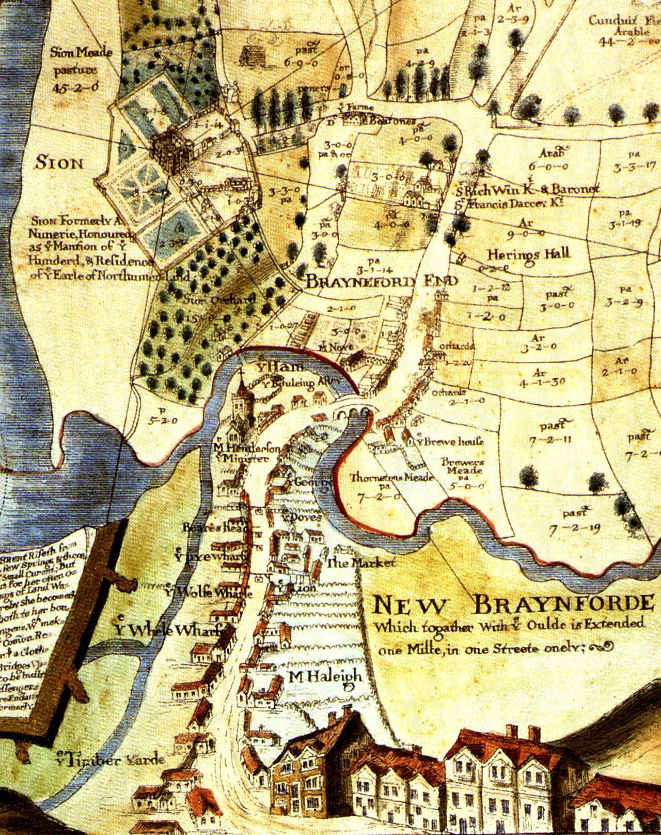
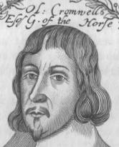
3. Events in 1643 went mostly for the King, but the tide turned in 1644 when parliament won a major victory at Marston Moor (near York) and again the following year at the battle of Naseby (Northamptonshire) using a new and stronger army called the New Model Army. Both battles were won by the parliamentarian cavalry under Oliver Cromwell. He was a brilliant commander and had highly disciplined troops. He believed that he had been chosen by God to free England of Charles’ reign.
4. Charles surrendered to the Scots, who had sided with parliament, in May 1646. Fighting flared-up again in 1648 after the King had persuaded the Scots to join his side. Because he had started the war again, Cromwell, the New Model Army and some in parliament decided Charles should be executed. He had been held prisoner on the Isle of Wight until being brought to London in 1649, put on trial and beheaded.
5. From 1649 to1660 England had no monarchy. Fighting continued in Scotland and Ireland and in 1651 the Scots tried to invade England to put Charles’ son, the future Charles II, on the throne. But Cromwell defeated the Scots at Worcester. In 1653 Cromwell was made Lord Protector of England – a king in all but name – until his death in 1658. Cromwell’s son tried to rule England after his father, but Charles’ son returned and was crowned King in 1660.

3. Events in 1643 went mostly for the King, but the tide turned in 1644 when parliament won a major victory at Marston Moor (near York) and again the following year at the battle of Naseby (Northamptonshire) using a new and stronger army called the New Model Army. Both battles were won by the parliamentarian cavalry under Oliver Cromwell. He was a brilliant commander and had highly disciplined troops. He believed that he had been chosen by God to free England of Charles’ reign.
3. Events in 1643 went mostly for the King, but the tide turned in 1644 when parliament won a major victory at Marston Moor (near York) and again the following year at the battle of Naseby (Northamptonshire) using a new and stronger army called the New Model Army. Both battles were won by the parliamentarian cavalry under Oliver Cromwell. He was a brilliant commander and had highly disciplined troops. He believed that he had been chosen by God to free England of Charles’ reign.
WEST
EAST
R
T
S
H
R
B
B
B
On this map:-
1. Label neatly the River Thames, River Brent, Syon House and Brentford Bridge.
2. Shade the rivers in blue.
3. Next to the arrows write ‘Royalist army’
4. The barricades have been marked by black lines. Label these ‘Parliamentary forces’

